Rossinver Youth & Community Project Newsletter – May 2021

 | @rossinverycp |  | Rossinver Youth and Community Project – RYCP |  | @RycpCentre

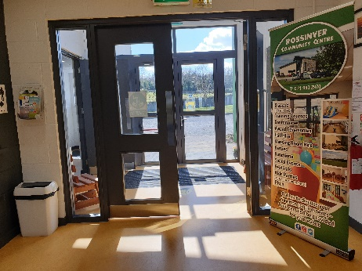 | 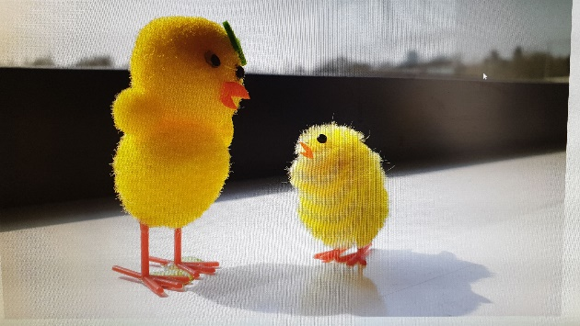 | 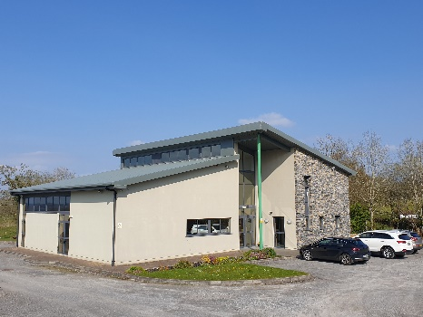
2020 – the Year we never expected

It has been over a year since we published our last newsletter, and never could we have imagined it would be a year before we could even consider issuing another one. We never anticipated the year that lay ahead. A lot of changes has been brought upon us all, some good, some bad. We have lost friends and family members and in one of the hardest periods to do so, where we couldn’t extend our arms to each other, to offer a shoulder to cry on, to extend our hands in sympathy and in receipt of same. It has been a strange, tough year for everyone, but with the vaccination roll out and the lockdowns we have all gone through together, we now hope that we are finally reaching a stage where we will be able to return to a level of normality.

For us here at RYCP, a lot has happened since we last seen activities taking place within our doors. We ran a series of successful weekly online Facebook Shows starting with Storytime every Monday for the younger children. We must commend story writers Daithi and Sarah Green, for bringing us “Coopers Adventures” and wow did he have some adventures! This talented duo also told us tales of the wonderful “Lily the Fairy”. Flynn and Morgan Chandler brought us the amazing stories of “Hot Wheels”, “Mastermind Shark” and of course, who could forget the “Classic Ninja Rabbit” and all his antics! We had so much fun anticipating each story and wondering what was going to happen next, these storytellers kept us on our toes! We also had some amazing recipes for a Food Trip Around the World every Wednesday, my favourite was the Lasagne with meatballs, Mmmm. We had fantastic music sessions every Thursday with Tune in Thursdays featuring local artists Megan Kilkenny, Sisters Caitlin, Maebh and Caoimhe Gilligan, Lily Keaney, Johnny Gallagher, Marion Fitzgerald, Charlie McGettigan, Pat McManus, Sean Gibbons. Photography Friday was also well received by the public and ended the week with some amazing, beautiful, and uplifting images of our countryside and villages, from shore to hills, to people and of course our adored pets. Thanks to Joseph Cohen, Maeve O Connor, Keery Irvine, Terry Hannah, Marty Rea, Kevin Warren, Andrea Whelan, and Astrid Vaessen for all their great images and message of support through the pandemic.

Every one of these shows every week was contributed to by you, our community, you helped to lift each other’s spirits up and give people something to look forward to. Thank you all for everything you contributed and the joy you brought into everyone’s lives! And thank you to everyone who watched, listened, joined in, and cooked, we hope you all enjoyed!

Town & Village Renewal 2020 & National Lottery Fund 2020
You may have noticed we now have installed a new garden area with wheelchair access and an exercise area down the back of the community centre thanks to funding issued by Leitrim County Council under the Town & Village Renewal Scheme 2020. Due to the lockdowns, we have not been able to fully complete the work, but we are almost there. Once finished, it will have seating areas to reflect and to take in all the wonderful sounds and smells of the garden and the nature around it, from the bird and insect boxes to attract extra wildlife to the gentle sound of the grasses rustling in the breeze and the flowerbeds.

The National Lottery Funding also awarded us some funds to install extra ramps to the community garden area. If there is one thing this pandemic has taught us all, it is that the outdoors and nature is vital to our health & well-being and we will do all we can here at RYCP to facilitate a place for the community to use and improve upon what we have.

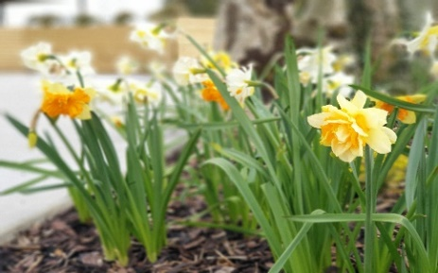 | 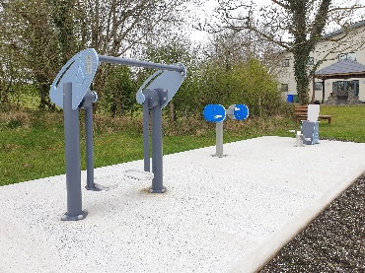 | 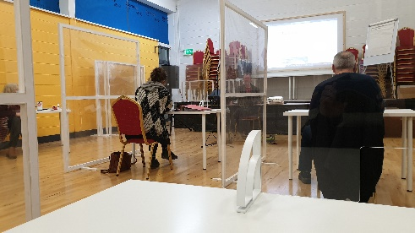
Within the four walls of RYCP, The Town & Village fund enabled us to purchase new desks, lockers, chairs, and translucent partition screens. We can now facilitate courses, meetings, hot desking, remote working areas in a safe & covid friendly manner. We had the opportunity to use these facilities last autumn, whilst it was different than the norm, it was great to be able to get back to learning within a classroom environment and it worked well. The funding also covered a complete overhaul of our wireless system within the building to maintain a good broadband speed no matter which of our rooms you work from. These projects are just a start, to which we hope and will endeavour to add to for the benefit of the community over the coming years. And we would just like to thank our funders, Leitrim County Council and The National Lottery for all their help and support throughout.

We now look forward to moving out of the current restrictions and being able to get back to onsite classes and meetings. If you are interested in booking any of these facilities or need a place to work remotely, please contact us at 071 983 2970 or contact us via email, or DM us on our Facebook, Instagram, or Twitter accounts (all contact details are at top of newsletter).

2021 – Looking Forward

National Spring Clean Week 2021  Thanks to Dympna Gilbride who organised everyone involved in the National Spring Clean day on Good Friday. Leitrim County Council supplied bags, gloves, Safety vests and manual litter picker sticks. There was plenty of help as the roadsides in and around Rossinver were cleared of rubbish. Some participants were surprised at the number of drinks cans and takeaway litter in the ditches. Thank you to everyone that helped on the day. We have a beautiful area to share with others and we would like to keep it that way. |  | 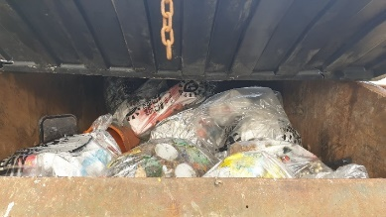
Leitrim County Council – Covid Fund 2021 Courses
Thanks to funding from Leitrim County Council, through the Covid Fund, we have been able to bring to you free classes online. These classes included Yoga with Niamh, Mindful Yoga with Ingrid and we had some amazing flower arranging workshops with Triona. The Yoga and flower classes which have finished up, were well received by all participants. This funding also brings to you stories from Gene Sheerin. We are planning many more classes with Triona for Halloween and Christmas so don’t miss out. Also watch this space for more Yoga with the wonderful Niamh and Ingrid as soon as guidelines allow.

Gene’s Storytelling
For the next few Tuesdays we will be adding new recordings on our Facebook page, from Rossinver native, Gene Sheerin, as he shares his great recitations with us from his own home. Gene is a great storyteller, and we are sure everyone will be fascinated at how many stories he tells from memory.
2021 – Courses, Training & Education

MSLETB Courses at RYCP – May 2021

Health and Safety Awareness Course inc. Manual Handling (QQI Level 3) - 27th & 28th May (1.5 days)
(Covid Regulations allowing)
Open to all (inc Businesses, Community Groups, etc)
Thurs 9:30am- 5:00pm, Fri 9:30am- 1:00pm.
Both days must be completed to attain the QQI Level 3 certification.

Tourism & Business Course (QQI Level 5)
This class started in 2019 and was abruptly stopped due to Covid 19 last March. The class are now back up and running online with their tutor and are currently covering the Heritage Module, having previously completed their Business Plan Modules.

Manual & Sage Accounts (QQI Level 5)
Manual Accounts has been completed and all going well with expected easing of Covid restrictions, we are aiming for May to get everyone back on site to complete the Sage Accounts part of this course. We will be running this course again next autumn all going well for anyone who missed out this time.

Child (Paediatric) First Aid Course - 18th May (Full Day)
This course encompasses what to do if a baby or child is choking, not breathing or unconscious, first responder actions for common accidents and injuries, recognising high risk signs of illness and assessing the injured or ill child. This Child (Paediatric) First Aid Course is designed for people who work with children and for parents or guardians who wish to have the confidence of knowing what to do in emergency situations.
Covers: Choking conscious, Choking unconscious, Paediatric CPR, Paediatric convulsions, Unconscious paediatric, Emergency services, Poisons, Burns, Question and Answer Session
Certificate: Safetech Certificate for Paediatric First Aid
Beauty Classes – as soon as restrictions allow
Dates to be arranged due to current Covid Restrictions. Register your interest now and we will contact you when we get dates confirmed. This is a must for you and your friends with so important dates ahead. Limited places available.
Found Art with Caroline Harvey - Thurs 22nd April
Found Art is all about creating art out of everyday objects found on our local beeches using glass, wood and stones. Recycling is the key word here and being able to create something beautiful for your home. We have a few places left in this workshop if anyone would like to start creating online in their own home whilst under the guidance of Caroline Harvey. Each class creates a new individual piece of art that will compliment your home or make that perfect personalised gift for a family member or friend my by your own hands.
Copper Etching with Caroline Harvey - from Thurs 22nd April
Using the medium copper engraving paper and etching tools we will explore how to create simple Celtic designs and motifs that look incredibly intricate. We will work on laying down your template, how to work free hand, and help you find and create your own unique designs. We have some places available if anyone would like to create a unique piece for their home or even a present for a family member or friend.
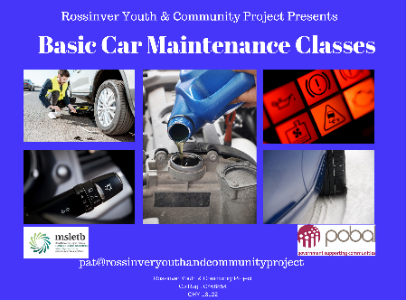
Basic Car Maintenance – as soon as restrictions allow

Register your interest now and we will contact you when we get dates confirmed. Basic car maintenance covers changing tyres, knowledge of warning lights, distinguishing the different fluids and where they go in an engine culminating in a better awareness and the responsibilities involved in maintaining your vehicle. Our tutor has over 40 years of experience in the motor trade and will guide you through the do’s and don’ts of everyday motoring.
Basket Making Workshop - Wed 8th Sept 2021
with Tom O Brien Starting for 6 classes. One of the oldest traditions in Ireland could be in your hands as you weave sally rods into beautiful baskets for your own use. Classes open to beginners and experienced alike. There is limited places available so book sooner than later.
Fly tying - Thurs 9th Sept 2021
Learn how to tie Flies with the renowned Jackie Mahon. This is a 6 week workshop and requires individuals to have experience in tying flies. Jackie will take you through the different types of Flies and how they are tied professionally which will enhance your chance of better days on the fly.
Discover Rossinver – Part 2 – as soon as restrictions allow
This class is a continuation of Discover Rossinver Part 1 which delves into learning more about Rossinver and its surrounding areas with our tutor and National Tour Guide Ciaran Rock. Did you know the diaspora of Rossinver reaches into south Co Donegal or that we have a sweathouse in the area and even an underground cave? There is much more to reveal and with the aid of this class we are sure discoveries are abound. Dates to be arranged for classes.
Flyfishing - Thurs 9th Sept 2021
Our 6 classes are ideally suited to those who have never fly fished before and would like an introduction to the sport. On the course you will learn - casting, tackle setup, how to choose correct tackle, safety, fishing techniques, and knots. Book soon to avoid disappointment.

To book any of our courses, facilities, training rooms, remote working hot desks please email pat@rossinveryouthcommunity.com or call us on 071 9832970 or if there is any course you would like to see ran, let us know and we will look into running here.
2021 – Events

Live at the Lake – July 2021

Our previous Live at the lake was a great success and we are thinking of running it again when it is safe to do so. We have the Tumbling Paddies booked and with that in mind even a Battle of the Townlands could be on the cards. As a community we needs days like this and if we can, we will make it a bigger and better event for all the family to enjoy.

Memorial Flowers
Once a year we make paper memorial flowers by hand. Each one can be dedicated to someone special to you by inserting a card onto the flower we provide, with your message on it. Just before we float them on Lough Melvin we place a small candle in the centre of the flower and release them one by one to appropriate music for the occasion.

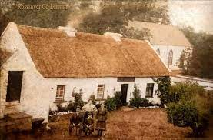
Heritage Week – August 2021
We are in the planning stages of holding a Heritage Week so all of the family can get involved, young and old. Owing to regulations we have to hold off for now but if we get the all clear prepare for a great week. Watch this space.

The Late Late Toy Show – Rossinver Style Nov 2021
If there is one thing, we all love is the spirit and magic of Christmas. Join us for one of our Biggest nights of the year when we host our own Toy Show Rossinver Style. Marion Fitzgerald is the perfect host as all our toy testers give their verdict on what’s hot and what’s not throughout the night. Local musicians and dancers take part in a fun filled night.

Watch this space for other upcoming events.

